Reel or Real? A Context-Aware Deepfake Detection and Verification Framework
- Introduction & Project Scope

The emergence of synthetic videos, images, and audio generated using advanced AI represents one of the most serious threats to digital authenticity and social trust in the 21st century. With deep generative models such as Generative Adversarial Networks, transformers, and diffusion networks producing near-perfect forgeries, misinformation can now be propagated at unprecedented speed and scale. The absence of reliable, explainable verification mechanisms threatens journalism, governance, and personal security.

This project proposes a context-aware deepfake detection and verification framework that integrates multimodal data analysis, explainable AI visualisation, and provenance verification. The goal is to deliver a technically accurate and socially interpretable system capable of detecting forgeries and explaining its decision-making to users. The framework will include a hybrid architecture combining CNNs and transformers, a lightweight interface for end-users, and evaluation across diverse datasets. The solution aims to be ethical, transparent, and deployable in real-world settings.

- Rationale & Background Research

The academic literature demonstrates rapid advances in deepfake detection yet persistent weaknesses in generalisation, transparency, and multimodality. Early CNN-based models such as VGG, ResNet, and Xception achieved high accuracy (93-97%) on curated datasets (Ahmed et al., 2022; Pan et al., 2020), but their performance degraded sharply on unseen data. Transformer-based architectures (Gong & Li, 2024; Zhang et al., 2025) improved temporal consistency and robustness but often remained “black boxes” with low interpretability.

Dataset diversity emerged as another barrier. Early benchmarks like FaceForensics++ and DFDC contained limited demographic representation and artificial manipulations (Lyu, 2020). Modern datasets such as KoDF (Kwon et al., 2021), HAV-DF (Kaur et al., 2024), and WildDeepfake (Zi et al., 2020) introduced realism and inclusivity, revealing that fair and representative data significantly improves model generalisation. Furthermore, FakeAVCeleb (Khalid et al., 2021) and HAV-DF demonstrated the importance of multimodal fusion for audio-visual correlation and cross-dataset resilience.

Recent work also shifts toward initiative-taking verification. Provenance standards such as C2PA (Laskar, 2025) and cryptographic watermarking (Walczyna et al., 2025; Wang et al., 2025) embed authenticity within the media itself. These advances demonstrate that future systems must move beyond post-hoc detection towards continuous validation frameworks combining detection, provenance, and explainability.

However, gaps remain. Existing models struggle to generalise to unseen forgeries; few fuse multimodal data effectively; interpretability is underdeveloped; and ethical concerns persist regarding bias and privacy. This project directly responds to these limitations by designing a hybrid, interpretable, and ethically aware framework capable of detecting and verifying deepfakes across varied contexts.

- Project Development: Approach & Evaluation

The project will adopt a modular architecture combining Convolutional Neural Networks for spatial feature extraction and transformers for capturing temporal dependencies. Preprocessing will include frame extraction, normalisation, and audio-visual alignment to ensure consistent input quality. Publicly available datasets such as FaceForensics++, DFDC, KoDF, and FakeAVCeleb will serve as the primary sources for training and testing. In addition, another dataset may be incorporated, consisting of videos, photos, and audio samples submitted by participants through a public survey that received over four hundred responses, pending final ethical approval from the University. This inclusion would enhance the dataset’s diversity and strengthen the model’s generalisability to real-world media. Explainability components such as Grad-CAM visualisations, attention maps, and confidence scoring, together with provenance verification via digital watermarking, will further enhance transparency, accountability, and user trust in the detection process.

Alternative approaches such as pure transformer or biological-signal detectors (Heidari et al., 2023) were reviewed but excluded due to hardware complexity and limited reproducibility. The hybrid multimodal approach ensures higher interpretability and stronger cross-dataset robustness.

Success will be measured using accuracy, F1-score, precision, recall, and robustness against compression or noise. Processing speed and user trust metrics will assess practical feasibility. Ethical considerations, including privacy, consent, and dataset fairness, will guide all implementation and testing stages.

- Feasibility, Planning & Gantt Outline

Development will be conducted in Python, using TensorFlow, PyTorch, and OpenCV on a GPU-enabled workstation. Publicly available datasets ensure no legal barriers. Ethical compliance will follow GDPR principles and university AI ethics policies, ensuring informed consent, anonymisation, and fairness.

All data used will be obtained from open research datasets that include explicit consent or simulated identities. The system will be designed for educational and protective purposes only, with no capacity for content generation. Fairness audits and bias testing will ensure fair performance across demographic groups.

Task | Duration | Key Activities | Expected Outputs
Proposal & Foundation | Weeks 1-5 (Oct-Nov) | Define project scope, conduct in-depth literature review, analyse existing datasets such as FaceForensics++, DFDC, KoDF, FakeAVCeleb, and design initial CNN-Transformer architecture. Prepare and submit the final project proposal. | Project scope statement, annotated bibliography, proposal submission.
Contextual Report & System Design | Weeks 6-13 (Nov-Jan) | Submit ethics documentation for survey dataset. Conduct detailed system design using UML and architectural diagrams. Implement and evaluate a baseline CNN model; compile contextual report. | Ethics submission, architecture diagrams, contextual report.
Implementation, Testing & Evaluation | Weeks 14-23 (Jan-Mar) | Build full data-processing pipeline; train and evaluate CNN, transformer, and multimodal fusion models. Conduct explainability integration and user studies to assess trust and usability. | Trained models, evaluation results, explainability visuals, user survey analysis.
Final Evaluation & Submission | Weeks 24-28 (Mar-Apr) | Consolidate quantitative (accuracy, F1, robustness) and qualitative (trust, usability) data. Write and proofread final report, prepare presentation slides, final demo, and submit all deliverables. | Final report, presentation, code submission, and project demonstration.

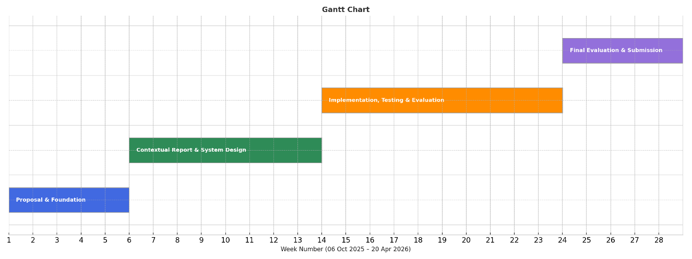

Potential risks include dataset imbalance, limited computational resources, and overfitting. Mitigation strategies include data augmentation, cloud-based training, and early stopping. The project’s structured timeline and modular design ensure successful completion within the academic year.

- References

Ahmed, S.R., Sonuç, E., Ahmed, M.R. & Duru, A.D. (2022) ‘Analysis survey on deepfake detection and recognition with convolutional neural networks’, Proc. International Congress on Human-Computer Interaction, Optimization and Robotic Applications (HORA).

Gong, L.Y. & Li, X.J. (2024) ‘A contemporary survey on deepfake detection: datasets, algorithms, and challenges’, Electronics, 13(3).

Heidari, A., Jafari Navimipour, N., Dag, H. & Unal, M. (2023) ‘Deepfake detection using deep learning methods: a systematic and comprehensive review’, Wiley Interdisciplinary Reviews: Data Mining and Knowledge Discovery, 14(2).

Khalid, H., Tariq, S., Kim, M. & Woo, S.S. (2021) ‘FakeAVCeleb: A novel audio-video multimodal deepfake dataset’, Proc. NeurIPS Datasets and Benchmarks Track, 1.

Kaur, S., Buhari, M., Khandelwal, N., Tyagi, P. & Sharma, K. (2024) ‘Hindi Audio-Video-Deepfake (HAV-DF): A Hindi Language-Based Audio-Video Deepfake Dataset’, arXiv preprint arXiv:2411.15457v1.

Kwon, P., You, J., Nam, G., Park, S. & Chae, G. (2021) ‘KoDF: A large-scale Korean deepfake detection dataset’, Proc. IEEE/CVF International Conference on Computer Vision (ICCV).

Laskar, P. (2025) ‘Cryptographic Provenance and the Future of Media Authenticity: Technical Standards and Ethical Frameworks for Generative Content’, Journal of Computer Science and Technology Studies, 7(6), pp. 967–972.

Lyu, S. (2020) ‘DeepFake detection: current challenges and next steps’, Proc. International Workshop on Media-Rich Fake News (MedFake), London: IEEE ICME.

Pan, D., Sun, L., Wang, R., Zhang, X. & Sinnott, R.O. (2020) ‘Deepfake detection through deep learning’, International Journal of Advance Research and Development, 4(6), pp. 4–8.

Walczyna, T., Zurada, J.M. & Piotrowski, Z. (2025) ‘RE-Mark: An Identity-Recovery Watermarking Method for Undoing Deepfake Face-Swap’, IEEE Access.

Wang, T., Cheng, H., Liu, M.H. & Kankanhalli, M. (2025) ‘FractalForensics: Proactive Deepfake Detection and Localization via Fractal Watermarks’, arXiv preprint arXiv:2504.09451.

Zhang, Y., Wang, T., Yu, Z., Gao, Z., Shen, L. & Chen, S. (2025) ‘MFCLIP: Multi-Modal Fine-Grained CLIP for Generalizable Diffusion Face Forgery Detection’, IEEE Transactions on Information Forensics and Security, 20, pp. 5888–5903.

Zi, B., Chang, M., Chen, J., Ma, X. & Jiang, Y.-G. (2020) ‘WildDeepfake: A challenging real-world dataset for deepfake detection’, Proc. ACM International Conference on Multimedia (MM ’20), pp. 2382–2390.

